MODULE 6
Q1. Capture and analyze ARP packets using Wireshark. Inspect the ARP request and reply frames when your device attempts to find the router's MAC address. Discuss the importance of ARP in packet forwarding.
- ARP stands for “Address Resolution Protocol”. It is used to determine the MAC address from an IP address.
- This protocol is used when a device wants to communicate with another device over a local area network.
When a sender wants to communicate, it first checks its ARP cache for the receiver's MAC address.
- If found, communication proceeds using that MAC.
- If not, the sender broadcasts an ARP request with its own MAC/IP, leaving the receiver’s MAC blank.
All devices on the LAN receive this request, but only the device with the matching IP responds with an ARP reply, providing its MAC address. The sender updates its ARP cache and can now communicate directly.
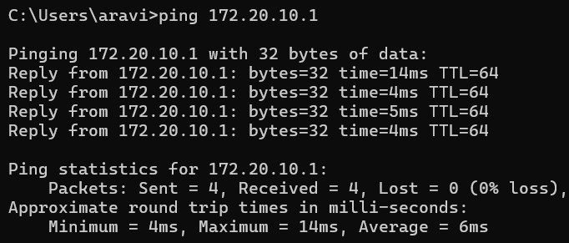
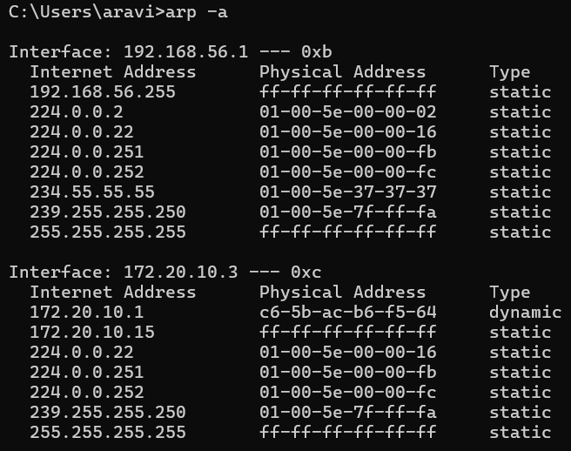

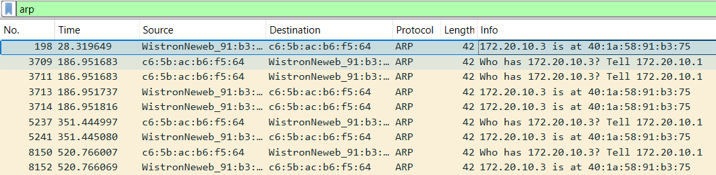
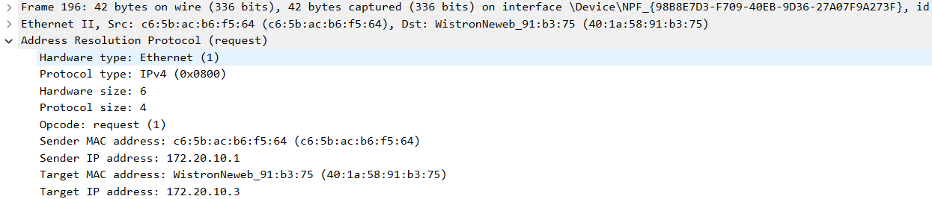
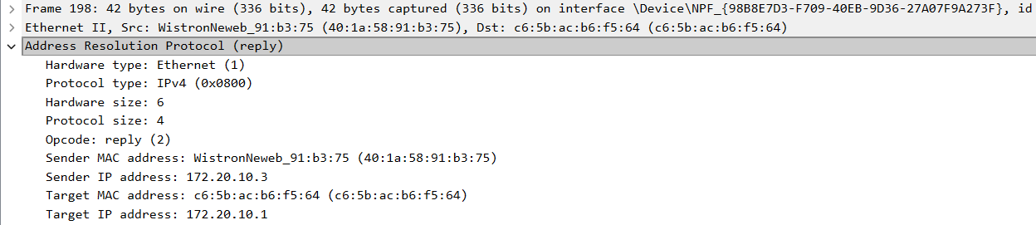

Q2. Manually configure static routes on a router to direct packets to different subnets.Use the ip route command and verify connectivity using ping and traceroute.
Routing is a process that shows how data packets are forwarded between different networks and devices. Routers are devices that perform routing.

Here I used Static routing since it is easy to perform in simple procedures .In static routing, I explicitly defined the path that data packets should take from one network to another.

I configured the router 5 and router 6 using the commands: Router 0:
enable
configure terminal
interface GigabitEthernet0/0
ip address 192.168.1.1 255.255.255.0
no shutdown exit

Router 1:
enable
configure terminal
interface GigabitEthernet0/0
ip address 192.168.2.1 255.255.255.0
no shutdown
exit
- I used ip route command in Router0 to configure Static Route to 192.168.2.0/24 via Router1:
ip route 192.168.2.0 255.255.255.0 10.0.0.2.
- I used ip route command in Router1 to configure Static Route to 192.168.1.0/24 via Router0:
ip route 192.168.1.0 255.255.255.0 10.0.0.1

PC0
IP Address: 192.168.1.10
Subnet Mask: 255.255.255.0
Default Gateway: 192.168.1.1
PC1
IP Address: 192.168.1.11
Subnet Mask: 255.255.255.0
Default Gateway: 192.168.1.1
PC2
IP Address: 192.168.2.10
Subnet Mask: 255.255.255.0
Default Gateway: 192.168.2.1
PC3
IP Address: 192.168.2.11
Subnet Mask: 255.255.255.0
Default Gateway: 192.168.2.1

Network setup:

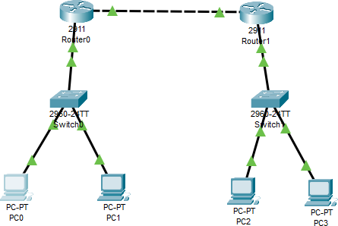

Configuring Router0:
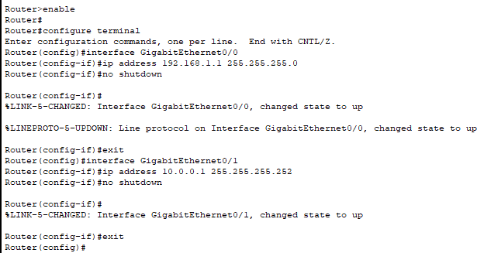

Configure Static Route to 192.168.2.0/24 via Router0:

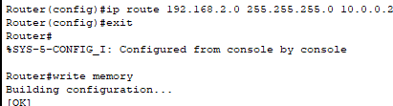

Configuring Router1:
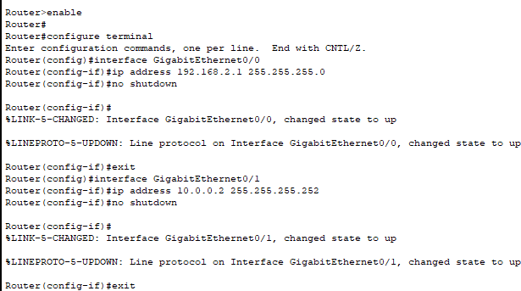

Configure Static Route to 192.168.1.0/24 via Router0:
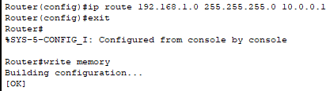

From PC0, pinging to PC2 and checking the path using tracert:
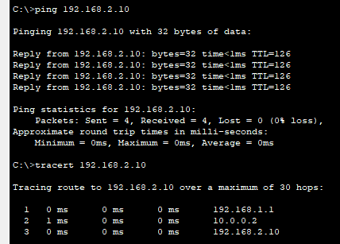

- 192.168.1.1 (Router0) → The default gateway for PC0
- 10.0.0.2 (Router1) → Router0 forwards the packet to Router1 via the link between routers.
- 192.168.2.10 (PC2) → Router1 sees that the destination is on its directly connected network (192.168.2.0/24) and forwards it to PC2.
On Router0, checking the routing table:
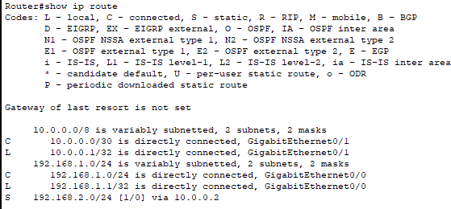

On Router1, checking the routing table:
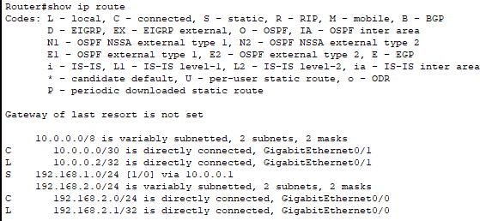

Q3. Given a network address of 10.0.0.0/24, divide it into 4 equal subnets. Calculate the new subnet mask. Determine the valid host range for each subnet. Assign IP addresses to devices in Packet Tracer and verify connectivity.
Given:
- Network Address: 10.0.0.0/24
- Subnet Mask: 255.255.255.0
- Binary Representation:
11111111.11111111.11111111.00000000

Determine Required Subnets
- Number of subnets needed = 4
- Formula:
$$2^{n}=4⇒n=2$$
- So, we borrow 2 bits from the host portion.
New Subnet Mask
- Original: /24
- New: /26 (24 + 2 bits)

Subnet Mask:
- Binary:
11111111.11111111.11111111.11000000
- Decimal:
255.255.255.192

Subnet Details
- Total IPs per subnet:
$$2^{6}=64$$
- Usable hosts per subnet:
$$64-2=62$$
Subnet Table
Subnet | Network Address | First Host | Last Host | Broadcast Address
Subnet 1 | 10.0.0.0/26 | 10.0.0.1 | 10.0.0.62 | 10.0.0.63
Subnet 2 | 10.0.0.64/26 | 10.0.0.65 | 10.0.0.126 | 10.0.0.127
Subnet 3 | 10.0.0.128/26 | 10.0.0.129 | 10.0.0.190 | 10.0.0.191
Subnet 4 | 10.0.0.192/26 | 10.0.0.193 | 10.0.0.254 | 10.0.0.255

Q4. You are given three IP addresses: 192.168.10.5, 172.20.15.1, and 8.8.8.8. Identify the class of each IP address. Determine if it is private or public. Explain how NAT would handle a private IP when accessing the internet.
192.168.10.5
- Class: Class C
- Public/Private: Private
172.20.15.1
- Class:Class B
- Public/Private: Private
8.8.8.8
- Class: Class A
- Public/Private: Public
- Description : Does NOT fall in any private range

- Private IP addresses are designated for local networks and cannot directly access the internet.
- Network Address Translation (NAT) enables devices with private IPs to connect to the internet by converting them into a public IP address.
Steps:
- A device with a private IP attempts to access an external website, such as 8.8.8.8
- The router, configured with NAT, swaps the private IP with its own public IP.
- The request is then sent over the internet to the destination IP.
- When the response comes back, it is directed to the router's public IP.
- NAT translates the public IP back to the original private IP and forwards the response to the correct device.

Q5. In Cisco Packet Tracer, configure NAT on a router to allow internal devices (192.168.1.x) to access the internet. Test connectivity by pinging an external public IP. Capture the traffic in Wireshark and analyze the source IP before and after NAT translation.
